* AB Test filter on session create date, whereas txn details report uses payment date; e.g. ORDER_KEY = 82727937, session create date 2017-11-30 23:59:10, while the payment happened 2017-12-01 00:01:40 EST from Vertica
* Turns out I didn’t filter out a lot of transactions on Dec 1 before 10:30 am because Excel is not sorting by date and time. The discrepancy count dropped from 330 to 127 after filtering out those transactions
* Some transactions is not captured by AB Extract because of timing and refreshing schedule; e.g. ORDER_KEY = 84537662
  + 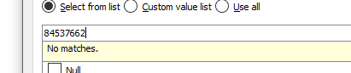
  + It’s not found in AB Extract while the last refresh of AB Extract data is 2017-12-11 6:43 AM
  + The session create time is 2017-12-11 00:56:05, but it’s not included in the extract